

**Favourite Drink**

What is your favourite drink? If you can, get some of it to help you complete this sheet!

What does it look like?

What does it smell like?

What does it taste like?

bland

fizzy

sour

sugary

tangy

delicious

fresh

fruity

musty

sweet

bright

dark

light

shiny

speckled

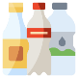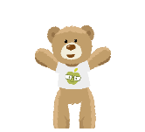

Draw a picture and describe your favourite drink.