

**Setting description**

Close your eyes and imagine you are in a forest or a wood. Use the space below to gather vocabulary and ideas.

**What can you see?**

Light glistening through the dense canopy.

**What can you hear?**

Branches creaking softly, leaves rustling like a never-ending whisper.

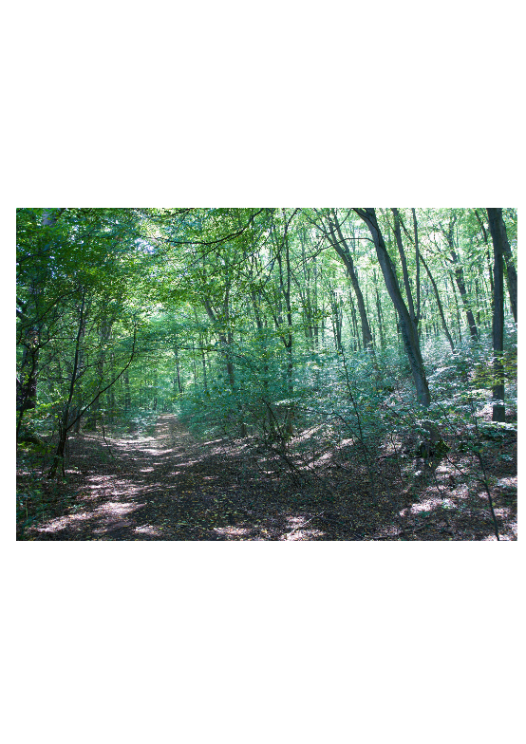



**Vocabulary**

colossal musty

crooked pungent

gloomy rustling

hollow shadowy

mumble tangled

murmur tranquil

**Sentence openers**

Astonishingly

In the distance

Beneath the dense canopy

Between the towering trees

On top of

Now use the ideas above to write your setting description paragraph. Try to include ambitious vocabulary and vary your sentence openers and punctuation.

**What can you smell?**

The damp, earthy ground and the sweet pine cones.

**How do you feel?**

A fresh, light fog seemed to envelope my body as my worries evaporated and disappeared.