Descriptive Writing Planning Sheet
Look carefully at your picture. Using the steps below plan some descriptive writing.
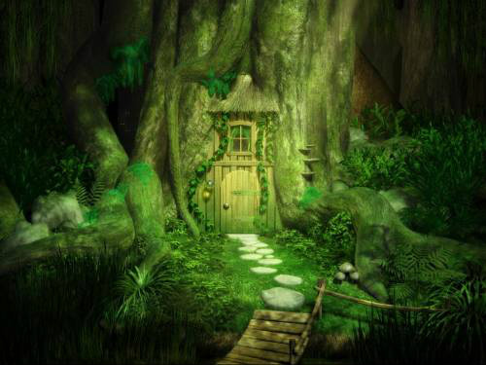
- Looking at your picture, jot down some simple words to describe what you might see, hear, or smell if you were in the scene.
E.g. Noise of a river

- Now, using a thesaurus or your imagination, add adjectives, adverbs or powerful verbs to describe each word.
E.g. Excited river babbling and gushing.

- Use your notes to create a paragraph of descriptive writing to describe the setting. Remember to use full sentences, including correct punctuation, and try to use a mixture of simple and complex sentences.

- When you have finished your piece, read it carefully to make sure it makes sense. Use a dictionary to check your spellings.

- Come up with an idea as to what you could use this setting for in a story.

