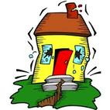
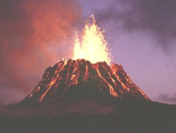
Year 3/4 Spring Newsletter

Dear Parents,

Next term Year 3/4's topic is Earthquakes and Volcanoes.
To start the topic off, I would like the children to come dressed as an aid worker, someone who would go and help in an area where there had been an earthquake. Come with some equipment that you would be helpful to people who were injured or had lost their home. This will be on the second day back at school, Friday, 6th January 2017.
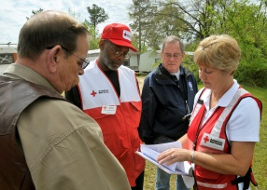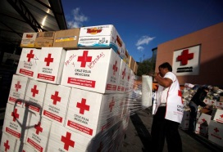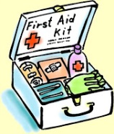

In Geography, we’ll be finding out:
  - About how the Earth is formed
  - What a volcano island is and where they are in the world
  - What causes an earthquake
  - How earthquakes can be measured
  - Why people continue to live in volcanic areas despite the dangers
  - About international organisations that work after natural disasters
In English, we’ll be finding out:
- About legends associated with volcanoes.
- Looking at, and writing news reports referring to earthquakes

In Science, we’ll be finding out:
- About how different types of rocks.
- How fossils are formed.
- What happens when a volcano erupts
- What happens when rock melts
- That soils are made from rocks and organic matter.
In History, we’ll be finding out:
- About the devastation of Pompeii
In Art, we’ll be finding out:
• About hot and cold colours
• About using different materials and techniques to represent a volcano

