Year 5/6

Spring Term Newsletter

This term our topic in Y5/6 is “Migration” and we will be looking into the following questions:
• What causes people to move?
• How do our Human Rights link to Migration?
• Why and what animals migrate?

In Literacy the Year 5/6 children will be focusing on Explanation texts, Argument/Debate, Reports and Journalistic writing.

For Maths we are beginning the big topic of fractions. We will be looking again at the four operations and the methods used for calculating these in relation to fractions. We will also be looking at improper and mixed number fractions and making sure we can convert between the two.

The Science focus will be on Inheritance and Evolution. This will link to our topic on Migration as we look at our bodies and that of animals and how they change and adapt to certain surroundings or lifestyles. Within this we will also look at the circulatory system. Art links nicely to our look at animals as we complete detailed drawings and paintings of migrating birds.

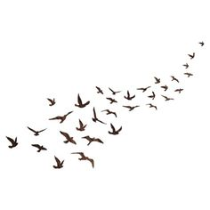
In RE we will be looking at what stories from the Bible reveal about Jesus? Also we shall link without Heart Stone project and talk about values and what matters most to certain individuals. In the run up to Easter we shall explore the resurrection in the Bible.
Days to Remember
Young Voices– 11/01/17
* Diocesan Day- 15/02/17
Robinwood– 03/04/17
Recorders– Thursday
P.E. Tuesday and Friday
* TBC

