Year 3 / 4 topic Autumn 2016

Next term our topic will be on pre- history. This is the Stone age, Bronze age and Iron age.
If you want to do some finding out about this over the holidays, please do, or go on some visits. There is some local information at Rudston church in east Yorkshire and you can see the Rudston monolith.
If you are travelling further afield, there is always the famous Stonehenge or Creswell Craggs in Derbyshire, but there are many other pre-historical places of interest.

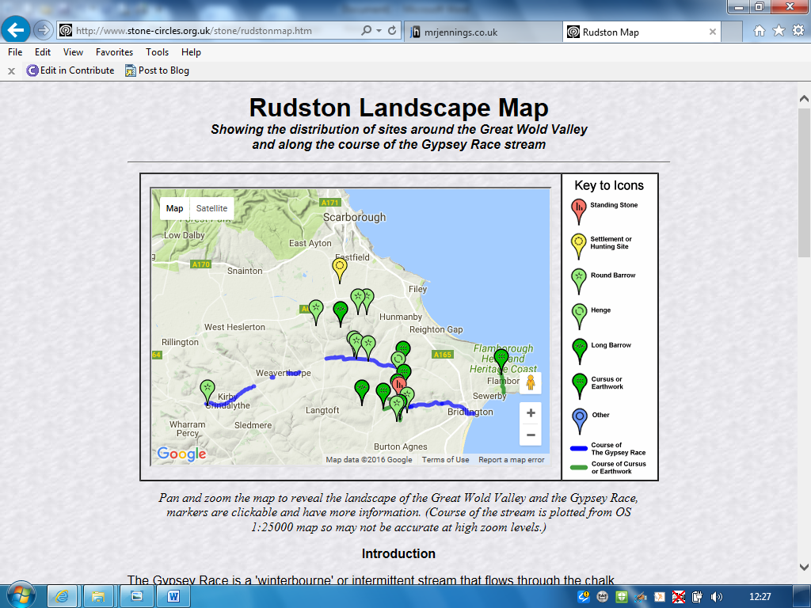

This is not compulsory, but might be of interest and will enhance the topic work next term.

J. Cordingley

