8th January 2016
Dear Parents,

This term, Spring 2016 the topic in Year 3//4 is “Treasures” with a focus on Ancient Egypt. We will be finding out about some of the treasures of Ancient Egypt, so as a starting point on the first day back, Tuesday 5th January I am asking that the children bring in something which is a “treasure” to them.. Also, at some point in the term we will be making a small treasure box; so if you have any suitable boxes, don’t throw them out!

We will have lots of exciting events and activities throughout the term.
If there is a parent who could help with 1 or 2 baking sessions on Tuesday afternoons, during the term, please get in touch with me.

Year 3 and 4 will be having tennis lessons at David Lloyd Sports Centre, starting on the last Friday of this ½ term, 12th February and on Friday afternoons throughout the 2nd half term. More details will follow nearer the time.

Yours sincerely

J. Cordingley

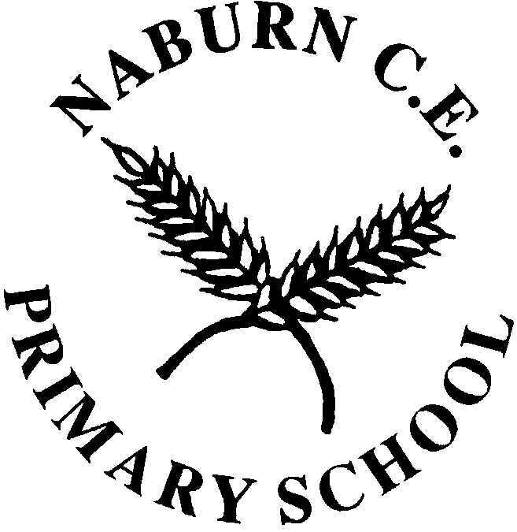  Small School Big Ideas |  | NABURN C.E. PRIMARY SCHOOL  Naburn  York  YO19 4PP  Tel: 01904 551075  Fax: 01904 633287  E-mail: naburn.primary@york.gov.uk  www.naburnschool.com  Headteacher: Mrs N Stephenson Barr

