Year 5/6 Spring Newsletter

Have you guessed our topic yet? Yes it is Whitby! We will be starting our topic by looking at the geography of the area and what features it has.
Linked to our focus on the coast, in Literacy the Year 5/6 children will be focusing on their argument and debate strategies as we look at new ideas to prevent coastal erosion.
In our numeracy work we will all be continuing with our calculation focus with division and multiplication. We will also be taking a closer look at fractions. At the end of the term the Year 6 will begin their SAT focus.

The Science focus will be linked to habitats for our Whitby project and also water resistance with our focus on erosion.

Our RE focus this term will be on what it means to be Muslim and Islamic and Christian Aid.
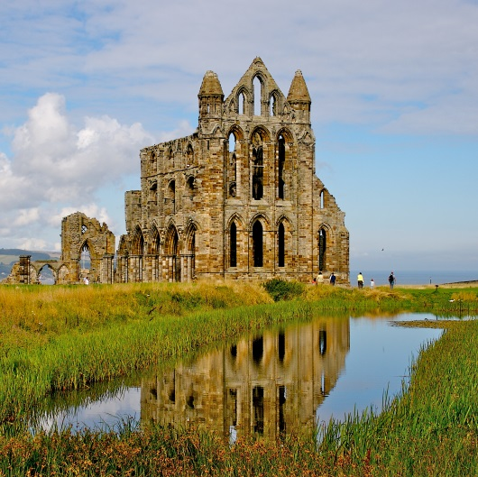

Important Events for the next term
• Tennis on Friday Afternoons at David Lloyds
• Year 5 Bikeability
• Year 5/6 Residential to Whitby
• YoYo “Its your Bible” workshop
• SATS

I shall be holding a meeting for parents and children to come after school about the layout and structure of the new SATS and how they will be marked. Date TBC.

