1. Here are two thermometers.
They show two different temperatures.

What is the difference between
the two temperatures?
……………………………degrees

2. Two thermometers show the temperature
inside and outside a greenhouse on a day in January.

How many degrees warmer was it inside the
greenhouse than outside?
………………………….. °C
Later the temperatures were
inside | outside
–1°C | –8°C
What is the difference between these two temperatures?
……………………………….°C

3. These are the temperatures in York
and Rome on a day in winter.

How may degrees colder is it in
York than in Rome?
………………………°C

On another day, the temperature
in York is 4°C
Rome is 7 degrees colder than York.
What is the temperature in Rome?
………………………°C

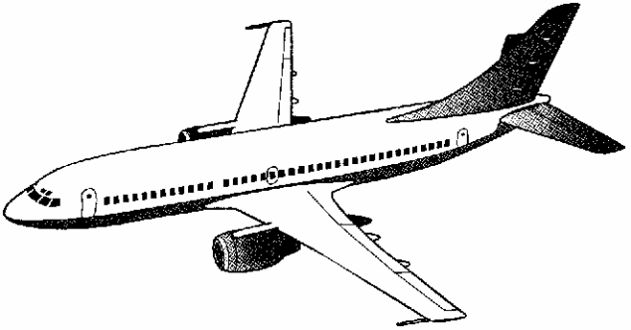
4. The temperature inside an aeroplane is 20 °C.
The temperature outside the aeroplane is –30 °C.
What is the difference between these temperatures?

………………………°C

5. Circle two numbers which have a difference of 2

–1 –0.5 0 0.5 1 1.5

- Order these numbers

-3 -6 7 2 -1

……………………………………..………………………………………………

- Circle the two numbers which have a difference of 3

–2 –0.5 0 1.5 2 2.5

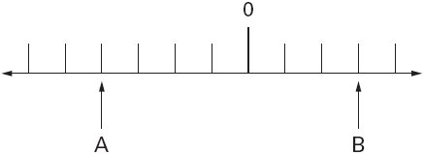
Extension Question
A and B are two numbers
on the number line below.

The difference between A and B is 140
Write the values of A and B.

