Fractions, Decimal and Percentages

- Complete the table

Decimals | Percentage | Fraction
0.5 | 50% | 50/100 = 1/2
0.25
 | 75%
0.1
 |  | 60/100
 | 15%

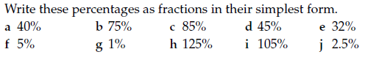

- Write these decimals as percentages
- 0.75 b. 0.345 c. 0.05 d. 0.6

a) Increase £200 by 50%

b) Increase 450cm by 25%

c) Increase 34kg by 72%

d) Increase 600miles by 48%

Hint: Find the percentage of the amount and then add it on to the original amount.

